***DOI: 3rd December 2019***

***Pawan Gosavi, Ashish Kamble***

*M.Sc. IT Part – I, Pillai’s ACS College, New Panvel.*

**Statistical Analysis of**

**Fuel Vehicle vs Electric Vehicle Adoption across the Globe**

**Abstract**

Nearly 80 percent of the global auto market is pushing toward a phase-out of petroleum cars and adoption of electric vehicles. If that comes to be, demand for gasoline and diesel would drop dramatically. This study carried out a survey on the adoption of electric vehicle in all over World. An Online Pole was conducted using google forms with several anonymous individuals associated with the electric vehicle to determine the factors affecting its widespread adoption throughout World. R software was used to analyze the data statistically and the three main factors discovered were Lack of Support Systems, High costs associated with the Electric Vehicle and Safety. The most feasible form of alternative energy to power the Electric Vehicle was determined as Solar Energy, and this was obtained using the pair-wise comparison method. Research done displayed that the Lack of future main Fuel Recourse systems was the main factor affecting electric vehicle adoption and by following the recommendations such as developing charging infrastructures, EV adoption can become a success throughout World.

**Keywords:** Solar energy; Charging infrastructures; Statistical analysis

**Introduction**

***Electric Vehicle (EV)*** is an alternative fuel vehicle that relies on electricity as energy resource. As such a large share of the automobile market will mean that there is a robust energy mix driving the cars of the future. EV is environment friendly, with zero tail-pipe emissions, but it relies on various sources of electricity generation. For EV to be ‘green’, the electricity should be generated from renewable energy sources.

Majority of today’s vehicles, power generators and plant machineries use internal combustion engines. Due to the vast utilization of internal combustion engines in the modern world, there are growing concerns over the impact of the exhaust emissions from internal combustion engines on human health and the welfare of the environment. These vehicles are powered via the burning of fossil fuels. Fossil fuels are considered as non-renewable resources since they take millions of years to form. However, their reserves are being exhausted faster than they are being generated and if this trend continues, the supply would run out within the next century.

The burning of fossil fuels releases carbon dioxide (CO2) emissions, a powerful greenhouse gas which vastly contributes to air pollution. Air pollution is a major environmental concern since it increases the risk for asthma and other respiratory diseases. Furthermore, the greenhouse gases traps heat in the atmosphere which makes the Earth warmer thereby significantly influencing climate change and global warming. In an effort to reduce the greenhouse gases on the environment nearly 80 percent of the global auto market is pushing toward a phase-out of petroleum cars and adoption of electric vehicles.

India, which is facing an air pollution crisis, says it wants to sell only electric cars within the next 13 years. This study carried out a research on the adoption of electric vehicles in across the Globe. Even though electric vehicles require the burning of gasoline to produce the electricity needed to drive it, they are emissions free and alternative energy can also be utilized to power the vehicle.

**Barriers to electric vehicle adoption**

However, several obstacles counteract the advantages of the EV that make the gasoline/diesel vehicle the most prevalent option between the two. Barriers to the implementation of EVs include Vehicle cost, limited Driving range, lengthy battery charging time and the need for a charging infrastructure at home, the workplace and public areas. The authors also further discussed that the disposal of the battery will pose as a threat to the adoption of the EV since the owner of the vehicle may have to pay to properly dispose of the battery.

Similarly, Uncertain government supports also plays a role in hindering the adoption of EVs. Mutawalli stated that State incentives are a big help that will subsequently encourage automobile customers to consider the option of purchasing the EV. Along with these factors, an additional barrier includes, cost of battery and maintenance.

Additionally, with the above factors also taken into consideration, Tsang et al. mentioned that safety concerns also hinder the up growth of the electric vehicles. They stated that Electrical safety is a concern since the batteries used for the operation of the EV are Lithium-ion batteries which could act as a potential hazard when overheated or short-circuited. Another safety concern is the absence of engine noise. For an EV, the induction motor replaces the conventional engine but is considered as very quiet compared to the engine. The authors claim that the absence of the noise from the engine acts as a safety hazard for pedestrians, especially to the physically impaired. These factors listed above confines the adoption of the Electric Vehicle. In an effort to secure its adoption in the future, each factor will be thoroughly researched in the hope of providing recommendations that will be made to satisfy and motivate the customer in purchasing the EV.

**Benefits of using electric vehicles**

Electric vehicles offer a wide range of benefits to both the user of the vehicle and the environment. It can be noted that even though gas is required to produce electricity in many countries, the consumers still benefit significantly using electricity to power their vehicles than the traditional way of using gasoline or diesel.

EVs are 100% Eco-friendly since they are driven by electrical motors. They produce no toxic harmful gases onto the environment making it a great alternative to the Gasoline/Diesel powered automobiles. The modern day EV has key advantages over the conventional gas/diesel powered vehicles, which include smoother and quieter operation, low operating costs, faster acceleration and the ability to refuel at your own home.

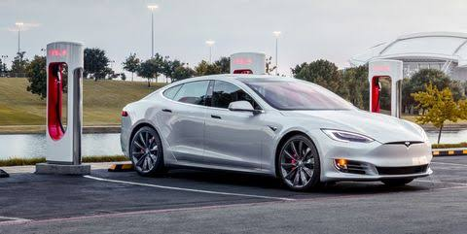

As stated above, a benefit of electric vehicles include gas not being required to power the vehicle. Although there are electric vehicles that use gas (hybrids), this project is solely based on Plug-in Electric Vehicles (PEV) which exclusively runs on electricity alone. In a few countries, alternative energy sources are used to power the EV but the majority of countries that utilize EVs produce their electricity by means of a gas-powered turbine. With this being said, consumers who use electric vehicles will see an increase in their electricity bill but the electric vehicle will be cheaper to run compared to traditional vehicles. In some countries, free charging is offered as seen in Norway. This greatly benefits the consumer since they would incur no charges on refuelling their electric vehicle.

Another benefit includes lower maintenance of an EV compared to standard vehicles. An electric vehicle has fewer moving parts than the regular petrol/diesel vehicles. This therefore means that the average electric vehicle owner will experience a greater savings since the EV would not require frequent maintenance. There is one cost that the EV owner would not be spared off which is the cost of replacing the lithium-ion battery used to power the EV. However, investigations proved that the minimum battery life of an electric vehicle is four (4) years and the maximum is twelve (12) years. Therefore, the EV user would only be charged a fee of replacing the battery for a minimum of every 4 years.

The electric vehicle also provides great benefits towards the environment. EVs significantly reduce the amount of emissions that contribute to climate change. Gasoline and Diesel powers vehicles emit a great amount of Carbon Dioxide onto the environment, the result of which includes global warming and climate change. These emissions also increase air pollution and severely deteriorate the health of the average person. Internal Combustion engine also include pollutants such as carbon monoxide, carbon dioxide and nitrous oxides. Carbon monoxide hinders the ability of the blood to carry oxygen and can cause permanent damage to the nervous system. The EV remarkably reduces the amount of emissions on the environment and if renewable energy is used to produce the power required for the EV, the greenhouse gases will be reduced even further.

Electric vehicles provide key benefits essential for both the consumer and the environment. These benefits will positively affect the lives of Trinbagonians if electric vehicle is to become the most popular mode of transport throughout the twin islands.

**Methodology**

This study seeks to discover the main factors affecting electric vehicle adoption in Across Globe. Additionally, it explored whether different characteristics impacts embarking future purchase of an electric vehicle. The required sample size to derive estimates within 5% margin of error from a population of 92 is 50.

**The measurement instruments**

The questionnaire was developed after a review of the literature pertaining to electric vehicle adoption. The questionnaire comprised of twelve (10) questions each designed to collect sufficient information on the factors affecting electric vehicle adoption and the main characteristics & Benefits that influence the purchase decision of an electric vehicle.

**Data collection method**

An Online Pole Survey was conducted with several individuals associated or non – associated with the electric vehicle to gather a better understanding about electric vehicle operation and to determine the factors affecting its widespread adoption throughout Across Globe. These factors were used to generate the questionnaire where a pilot test was conducted using 10 questionnaires to determine any flaws or weaknesses that may affect the validity of the study. The questionnaire was self-administered and distributed via google docs on November 2019.

**Methods of data analysis**

A. Cross-tabulations were used to examine the nominal and scale variables to assess whether there exist any relationships between the variables.

B. Principal Component Analysis or Factor Analysis was used to evaluate the 14 factors that affected electric vehicle adoption to determine which was the most important.

**Discussion and Analysis**

**Knowledge of an EV and Knowledge of an Electronic pump**

Crosstab analysis was conducted to evaluate the pattern of association between Knowledge of an EV and Knowledge of an Electronic pump as shown in Table 1. It was observed that respondents were more likely to know of an electric pump when they already know about electronic vehicles as shown in figure 1A and 1B. Conversely, respondents were more likely not to know of an electric pump if they don't know about electronic vehicles.

A 2 × 2 chi-square test shown in Table 1B was used to evaluate whether there was a significant relationship between Knowledge of an EV and Knowledge of an Electronic pump. The results reveal that there is a significant relationship between Knowledge of an EV and Knowledge of an Electronic pump, X-squared = 96.211, df = NA, p-value = 0.0004998.

|  |  |  |  |  |
| --- | --- | --- | --- | --- |
| Table 1 | Knowing of E Pumps | | | |
| Knowledge of EV Cars |  | NA | No | Yes |
| NA | 2 | 0 | 0 |
| No | 0 | 6 | 1 |
| Yes | 0 | 38 | 45 |

|  |  |  |  |
| --- | --- | --- | --- |
| Table 1B | X-squared | DF | p-value |
| Pearson's Chi-squared test | 96.211 | NA | 0.0004998 |

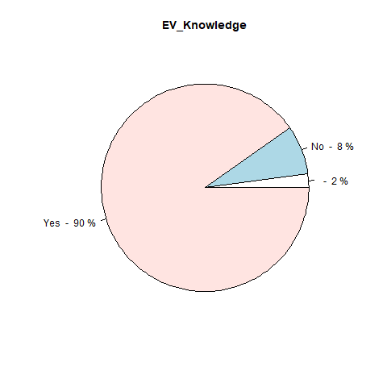

Figure 1 A

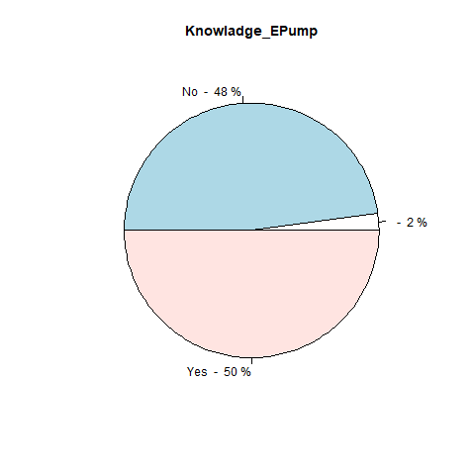

Figure 1 B

**Electronic vehicle vs Fuel vehicle and Electronic pump vs Fuel Pump**

Crosstab analysis was conducted to evaluate the pattern of association between Electronic vehicle vs Fuel vehicle and Electronic pump vs Fuel Pump as shown in Table 2. It was observed that respondents were more likely to choose an electric pump when they already know about Electronic vehicle vs Fuel vehicle and Electronic pump vs Fuel Pump as shown in figure 2A and 2B. Conversely, respondents were more likely to choose a Fuel pump as better option if they don't know about electronic vehicles.

A 2 × 2 chi-square test shown in Table 2B was used to evaluate whether there was a significant relationship between Electronic vehicle vs Fuel vehicle and Electronic pump vs Fuel Pump. The results reveal that there is a significant relationship between Electronic vehicle vs Fuel vehicle and Electronic pump vs Fuel Pump, X-squared = 31.335, df = NA, p-value = 0.0004998.

|  |  |  |  |  |
| --- | --- | --- | --- | --- |
| Table 2 | Pump Type | | | |
| Vehicle type |  | NA | Electronic_Pump | Fuel_Pump |
| NA | 2 | 0 | 0 |
| No | 0 | 2 | 6 |
| Yes | 4 | 38 | 40 |

|  |  |  |  |
| --- | --- | --- | --- |
| Table 2B | X-squared | DF | p-value |
| Pearson's Chi-squared test | 31.335 | NA | 0.0004998 |

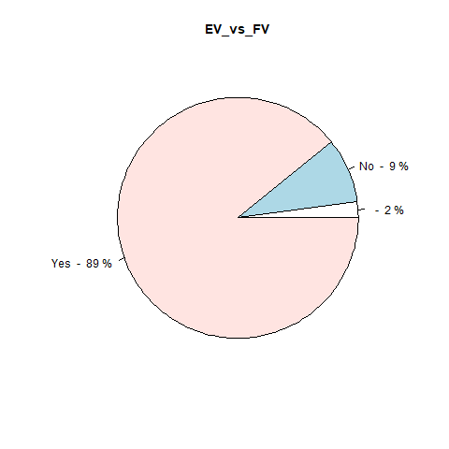

Figure 2 A

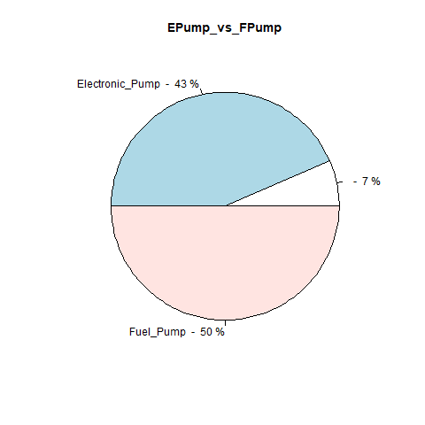

Figure 2 B

**Hybrid Cars and Gear Types**

Crosstab analysis was conducted to evaluate the pattern of association between Hybrid Cars and their Gear Types as shown in Table 3. It was observed that respondents were more likely to choose an Automatic Gear when they choose hybrid cars as an option as shown in figure 3A and 3B. Conversely, respondents were more likely to choose a Fuel pump as better option if they don't know about electronic vehicles.

A 2 × 2 chi-square test shown in Table 3B was used to evaluate whether there was a significant relationship between Hybrid Cars and their Gear Types. The results reveal that there is a significant relationship between Hybrid Cars and their Gear Types, X-squared = 68.441, df = NA, p-value = 0.0004998.

|  |  |  |  |  |
| --- | --- | --- | --- | --- |
| Table 3 | Gear Types | | | |
| Hybrid Cars |  | NA | Automatic | Manual |
| NA | 3 | 1 | 0 |
| No | 0 | 5 | 3 |
| Yes | 0 | 54 | 26 |

|  |  |  |  |
| --- | --- | --- | --- |
| Table 3B | X-squared | DF | p-value |
| Pearson's Chi-squared test | 68.441 | NA | 0.0004998 |

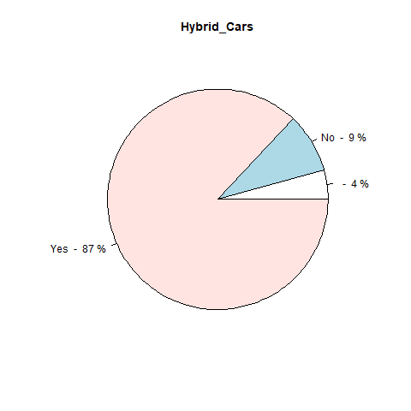

Figure 3 A

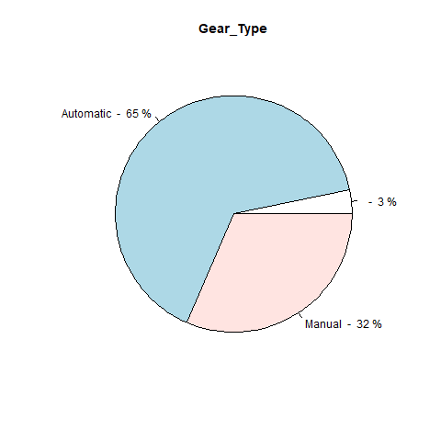

Figure 3 B

**Reduced Air pollution by Using EV and EV Replacing Fuel vehicle**

Crosstab analysis was conducted to evaluate the pattern of association between Reduced Air pollution by Using EV and EV Replacing Fuel vehicle as shown in Table 4. It was observed that respondents were more likely to choose an EV when they Know that Air pollution is Reduced by EV as shown in figure 4A and 4B. Conversely, respondents were more likely to choose a Fuel vehicle as better option if they don't know about Reduced Air pollution from EV.

A 2 × 2 chi-square test shown in Table 4B was used to evaluate whether there was a significant relationship between Reduced Air pollution by Using EV and EV Replacing Fuel vehicle. The results reveal that there is a significant relationship between Reduced Air pollution by Using EV and EV Replacing Fuel vehicle, X-squared = 92.706, df = NA, p-value = 0.0009995.

|  |  |  |  |  |
| --- | --- | --- | --- | --- |
| Table 4 | Replacing FV with EV | | | |
| Reduced Air Pollution |  | NA | No | Yes |
| NA | 2 | 0 | 0 |
| Maybe | 0 | 2 | 8 |
| No | 0 | 0 | 3 |
| Yes | 0 | 14 | 63 |

|  |  |  |  |
| --- | --- | --- | --- |
| Table 4B | X-squared | DF | p-value |
| Pearson's Chi-squared test | 92.706 | NA | 0.0009995 |

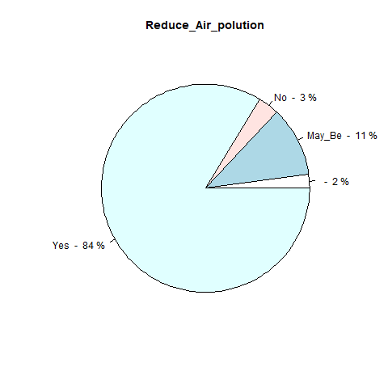

Figure 3 A



Figure 3 B

**Safety**

The purpose of safety is to prevent accidents at any cost. For vehicles, this is considered in the design and manufacturing process. After each vehicle is manufactured, thorough inspection is conducted to ensure that the vehicle meets the required standards such as the ISO 26262. The ISO 26262 is an international standard that address safety hazards caused by the malfunctioning of Electrical safety related systems (International Organization for Standardization) For electric vehicles, the process is similar however; different countries implement different systems in place to ensure that the electric vehicle is safe for use.

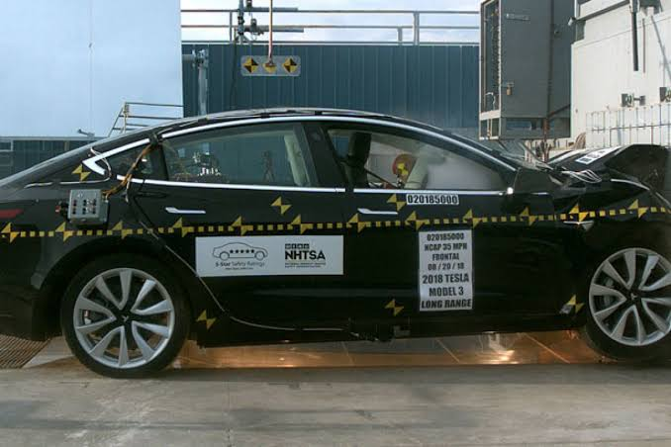

Crash Test for Tesla Model 3

**Renewable energy**

The aim of this section is to determine the most suitable form of alternative energy to power the electric vehicle which involves the use of the pair-wise comparison chart (Table 5A and 5B, 5C). The different forms of renewable energy include:

- Solar

- Wind

- Hydropower

- Geothermal

- Biomass

- Nuclear

**Defining metrics**

1] **Quality of life**: 1-Hazardous impact on human life, 2-Medium risk to human life, 3-Low risk to human life.

2] **Plant safety**: 1-High probability of accidents occurring, 2-Medium probability of accidents occurring, 3-Low probability of accidents occurring. Maintainability: 1-High Maintenance, 2-Mediium Maintenance, 3- Low Maintenance

3] **Environmental impact**: 1-High Environmental Impact 2-Medium Environmental Impact, 3-Low Environmental Impact

4] **Noise**: 1- High noise pollution, 2- Medium noise pollution,3-Low noise pollution

5] **Cost**: 1- High cost, 2- Medium cost, 3- Low cost

6] **Power generation**: 1-Low Power Generation, 2-Medium

|  |  |
| --- | --- |
| **Criteria** | **Description** |
| Quality of Life | The effects on the quality of human life. |
| Plant Safety | The possibility of the system causing an accident. |
| Maintainability | The continuation of the system after implementation. |
| Environmental Impact | The impact on the environment after implementation of the system |
| Noise | Noise pollution due to execution of the system |
| Cost | Finances associated with the purchasing and installation of the system |
| Power Generation | The ability of the system to continuously produce power. |
| Accessibility | Considers whether the system can be conveniently located in a given area. |

Table 5A: Criteria used for the pairwise comparison chart

|  |  |  |  |  |  |  |  |
| --- | --- | --- | --- | --- | --- | --- | --- |
| Attributes | Relative Weighting | Solar | Wind | Hydro Power | Geo thermal | Biomass | Nuclear |
| Quality of Life | 0.22 | 3 | 3 | 3 | 2 | 3 | 1 |
| Plant Safety | 0.22 | 3 | 3 | 3 | 2 | 3 | 2 |
| Maintainability | 0.05 | 3 | 3 | 1 | 3 | 1 | 1 |
| Environmental Impact | 0.17 | 3 | 3 | 3 | 2 | 3 | 1 |
| Noise | 0.01 | 3 | 2 | 1 | 1 | 2 | 1 |
| Cost | 0.11 | 2 | 3 | 3 | 2 | 2 | 1 |
| Power Generation | 0.11 | 2 | 2 | 2 | 3 | 3 | 3 |
| Accessibility | 0.11 | 3 | 1 | 1 | 1 | 2 | 1 |
| Total |  | 22 | 20 | 17 | 16 | 19 | 11 |

Table 5B: Renewable Energy Selection (Selection Matrix)

|  |  |  |  |  |  |  |
| --- | --- | --- | --- | --- | --- | --- |
| Attributes | Solar | Wind | Hydro Power | Geo thermal | Biomass | Nuclear |
| Quality of Life | 0.66 | 0.66 | 0.66 | 0.44 | 0.66 | 0.22 |
| Plant Safety | 0.66 | 0.66 | 0.66 | 0.44 | 0.66 | 0.44 |
| Maintainability | 0.15 | 0.15 | 0.05 | 0.15 | 0.05 | 0.05 |
| Environmental Impact | 0.51 | 0.51 | 0.51 | 0.34 | 0.51 | 0.17 |
| Noise | 0.03 | 0.02 | 0.01 | 0.01 | 0.02 | 0.01 |
| Cost | 0.22 | 0.33 | 0.33 | 0.22 | 0.22 | 0.11 |
| Power Generation | 0.22 | 0.22 | 0.22 | 0.33 | 0.33 | 0.33 |
| Accessibility | 0.33 | 0.11 | 0.11 | 0.11 | 0.22 | 0.11 |
| Total | 2.78 | 2.66 | 2.55 | 2.04 | 2.67 | 1.44 |

Table 5C: Renewable Energy Selection (Weighted Metrics)

**Conclusion**

The aim of this study was to determine the main factors affecting electric vehicle adoption in Across Globe. This was done by utilizing the R software for statistical analysis where Cross-tabulations were executed to determine traits affecting electric vehicle adoption and Principal Component Analysis was conducted to determine the main factors affecting EV adoption. The analysis conducted displayed that no human factors such as age and gender influences the purchase decisions of an electric vehicle. The main factors determined from the principal component analysis included Support Systems, Costs associated with the electric vehicle and Safety.

Support systems includes the charging infrastructure of the EV, Government Incentives and the provision of proper maintenance and servicing systems. Currently there exists no charging infrastructure for the EV which is one of the major reasons of little adoption of the EV today. The government has provided incentives which reduce the total cost of the electric vehicle however this would not be fully utilized until charging infrastructures are developed throughout Across Globe. The incentives offered by the government include the removal of taxes on the vehicles which significantly reduces the total cost of the vehicle. However, no concern was placed on the cost of the EVSE systems. These systems are quite expensive and therefore should be evaluated so as to provide incentives to reduce its cost. There is currently a lack of technicians available to service and maintain the EVs. Programmes must be developed to educate technicians on the proper procedures and equipment to use when conducting service and repairs on these vehicles.

From the Principal Component Analysis, high costs act as another factor which affects EV adoption. It must be noted that during the data collection phase of this project, automobile car dealers pointed out that high costs remain as a factor to EV adoption since people are unaware of the existence of the incentives imposed on EVs. This was tested on the questionnaire where the results revealed high costs as a factor affecting electric vehicle adoption. The employment of incentives can only be considered effective when the population of Across Globe is aware of its presence. From the cost-analysis done, the results showed that electric vehicles are cheaper than conventional vehicles and also cheaper to maintain. The main problem is not associated with the cost of the vehicle but rather the population not being aware of its presence. Therefore, advertisements or other techniques should be implemented to ensure that more people become aware of its availability.

Safety was determined as another factor of EV adoption. It was concluded that Type Approvals are essential in validating the electrical systems in an EV, by comparing it to certain specifications before licensing the vehicles. This procedure should be employed in Across Globe to ensure the vehicle is electrically sound for use on the roadways.

The renewable energy that was determined as most feasible to power the electric vehicle was Solar Energy.

This form of energy can be utilized in Across Globe due to the natural weather conditions that comprises of mostly sunny days. This is a great form of renewable energy due to the wide availability of energy from the sun and with the proper incentives and programs in place, can become a great source of powering EVs.

**References**

1. Adeyanju AA, Manohar K (2017) Biodiesel production and exhaust emission analysis for environmental pollution control in Nigeria. Am J Engg Res 6: 80-94.

2. Natkunarajah N, Scharf M, Scharf P (2015) Scenarios for the return of lithium-ion batteries out of electric cars for recycling. Procedia CIRP 29: 740-745.

3. http://www.unep.org/publications/ebooks/emissionsgapreport2013/

4. https://martectraininguk.files.wordpress.com/2015/01/martec_hybrid_ trifoldinside_proof.jpg

5. https://ttec.co.tt/default/

6. Lebeau P, Macharis C, Van Mierlo J, Lebeau K (2013) Electric vehicles for logistics: a total cost of ownership analysis. Proceedings of the BIVEC-GIBET Transport Research Days 307-318.

7. https://www.iso.org/standard/43464.html

8. Emir F (2013) Selecting renewable energy sources for small islands using analytical hierarchy process (AHP).

9. http://estation.com.au/home-battery storage.

10. https://www.eia.gov/energyexplained/index.cfm?page=diesel_environment

